INTRODUCTION
In todays’ modern era Education becomes most important for the development of the society but higher education is the essential element for the sustainable development of the economy. Whereas higher education is becoming costly day by day this creates the need of loan. That is why, government promoting various Education loan schemes to protect the interest of students for higher education in different field the study.
Now a days, craze of education loan is increasingly arises day by day due to increasing fee structure of higher education but its need arises a long time ago. Student loan is started by SBI Bank since 1995 and after that many banks have started loaning scheme for needy and meritorious students in India. The government of India with the consultation of Indian Bankers’ Association and Reserve Bank of India framed a comprehensive loan scheme in 2001. But it is observed that non-performing assets enlarges rapidly in the field of education loan. This is the reason behind Indian Bankers’ Association has revised the educational loan scheme in 2004-05. For aforesaid reason of non-performing asset, Chairperson Usha Ananthasubramanian a state level bankers’ committee (SLBC) convey a strong message to banks of Punjab and Haryana when she told in a committee meeting that-
“The non-performing assets level is certainly on the higher side in case of education loan advanced collateral free. Only the meritorious rather than the deserving candidates should be considered for granting education loan”.
Now a days student loan becoming one of the most popular and the fastest growing retail banking products. As we have seen in the banking market that almost all public and private sector banks are handling out the student loans at glamorous rates of interest to meritorious student for studying in India as well as out of India. To sanction education loan to student having interest of higher education, government have taken a great step towards this is of nationalisation of commercial banks and Major commercial banks were nationalized on July 19, 1969 to build up a special and unique shape of priority sector concept and also included this in the lending programmes.

EDUCATION LOAN AND ITS FRAMEWORK
The Education loan is a type of loan designed to help the students in respect of paying their post-secondary education fees and other associated fees such as -
- Exam fees
- Library fee
- Lab fees
- Caution deposits
- Institution refundable deposits
- Administrative charges
- Travelling expenses concerning with education purpose
- Purchase of Books/Equipment/Uniform etc.
- Procurement of computers and all other reasonable expenses required to complete course.
Students’ loan is different from other type of loan as education loan is facilitated at lower interest rate in compare with other type of loans excluding home loan. The interest rate of education loan may be differing from one country to another country. Bank help the student by providing them student loan which cover all the expenses incurred during the course of education mentioned in the documentary proof. Banks sanctioned loan to the student for carrying out their desired educationally when the student have presented their counselling letter, admission letter, payment receipt of the fee of the particular university with the approval of that university.
CRITERIA OF EDUCATION LOAN
Loans are made available by banks to support Indian nationals for pursuing in approved and professional courses of undergraduate and postgraduate degree and PG diplomas conducted by reputed colleges and universities recognized by UGC/AICTE/AIBMS/ICMR/Govt. etc. and other Reputed professional and technical courses are also taken into consideration in India and loans are also granted to meritorious student for studying in reputed and recognized foreign universities as per the wants and desire of student. The loans are provided for the different professional courses of under graduate and post graduate such as, Engineering, Architecture, Hotel management, Management, BCA, MCA, Arts and Commerce, Pure sciences, Agriculture , Fine art and also for Research and development courses.
Approval can be checked on www.ugc.ac.in, www.education.nic.in, www.aicte.org.in. Indicative list is available at www.webometrics.info
REQUIREMENT OF DOCUMENTORY PROOF FOR EDUCATION LOAN
Banks demanded certain documentary proof for sanctioning the education loan. Documents that are required for granting the loans are income certificate of the guarantor( guarantor may be parents or other person), birth certificate of student for age proof, students latest mark sheet for residential proof, admission letter of the particular institute from where student qualifying the entrance test, the document containing or representing the expenses relating to the course work. In the case of abroad studies the students are required to impart endorsement from the related university’s head of the department, approved documents of visa and travel and also GRE\GMAT\SAT like entrance test scores. Inspite of this, the applicant should must be submitted a declaration or affidavit that the student is not getting any financial support from any other banks and any other necessary documents as per the requirement of particular bank from where student taking loan.
QUANTUM OF FINANCE
Banks allotted Rs. 10 lakhs for study in India and permitted Rs. 20 lakh for studying abroad. Banks may lend higher amount of loan in special cases at their circumspection.
SECURITIES:
- Up to Rs. 4 lakhs amount, there are no security charges but in this case parents need to be a joint borrower.
- Starting from Rs. 4lakhs to 7.5 lakhs, along with parent(s) collateral security in form of third party guarantee are needed.
- Above Rs. 7.5 lakhs, Parents are to be joint borrowers and tangible collateral securities of suitable value are prerequisite, along with the assignment of future income of the student for payment of instalments.
DISBURSEMENT OF LOAN
Educational loan is a type of loan which uniquely facilitating the disbursement system that individual can repay the amount of loan not immediately as it is sanctioned but after course completion or six months after obtaining employment. Additional goodness of this disbursement is that these are available for long period of 10 or 15 years or even more. Repayment tenure of loan have also included moratorium period in it. Speedy loans are provided by several banks with free service. Sometimes the banks can directly disburse the loan to the institution depending on fee schedule concerning the time of loan approval.
Educational loan is also similar to other type of loans considering principal amount and interest rate but difference is that there are chances to postpone the repayment of loan until after one year of completion of course tenure. There is also the option that the applicant can start repaying immediately after loan sanctioned. It’s up to the applicants that when he may want to starts repayment. Basically there are three ways for the payment of loan. -
- Generally bank permitted the individual 1year from completion of course or six months of getting jobs whichever is earlier for the repayment of loans.
- Interest amount of the loan either are to be paid during the course period or started just after one year of course completion along with the principal amount.
- As soon as the loan is sanctioned the EMI starts. This option may cause of lowers the interest rate of loan sanctioned.
- If interest is serviced during the tenure of study and consequently follows moratorium period prior to initiation of disbursement, bank may have provided of 1% interest concession to the individual.
If the students are not able to complete the course within the predetermined period, there is provision of extension made for permitting the maximum period of 2 years for completion of course. In case the student terminates the course in mid of the tenure, relevant reimbursement schedule will be worked out by the bank in deliberation with the student and parents.
Note: There is no penalty charged for advance payment of loan during the reimbursement period.
MORATORIUM PERIOD FOR DISBURSEMENT:
Moratorium period for disbursement of loan are fixed by government that is after 1 year of completion of course work or 6 months after getting employment, whichever is earlier.
MARGIN MONEY
- Margin money is Nil for loan up to Rs. 4 lakhs.
- Interest of 5 % and 15 % are to be charged for study in India and abroad respectively on the loan taken above Rs. 4 lakhs.
- Margin includes scholarship.
- Margin may be on yearly basis as where disbursements are made on pro-rata basis.
- Also the cases where the loan amount is higher than 20 Lakhs to study abroad the percentage of interest are to be calculated on the basis as the bank sets a margin.
TENURE OF LOAN
There are 10 years to 15 years tenure for loan disbursement up to Rs 7.5 lakhs and above respectively. In accordance with the section 80(e) of the Indian income tax act, a person can exempt the amount paid against the interest of the education loan – either for self or for his/her spouse or children – for 8 years from the year he started the payment of loan or for the duration from which the loan is in the effect, whichever is more.
TRENDS OF EXPENDITURE ON EDUCATION LOAN
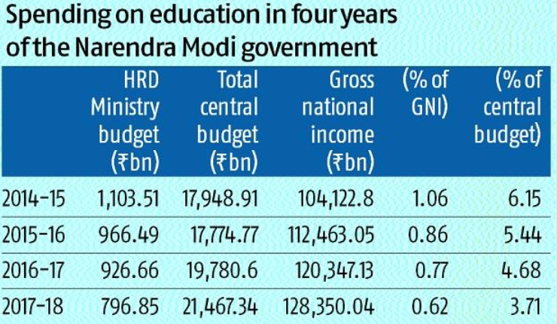
Source: (Business Standard , 2018)

