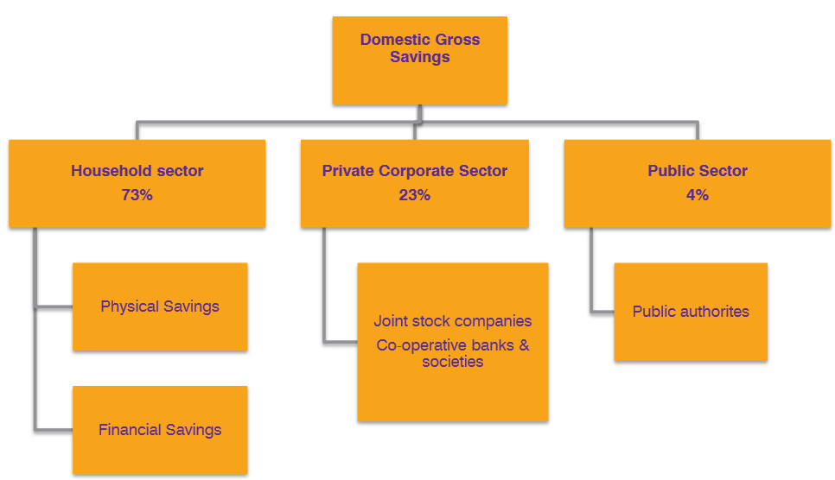

Subject Matter of Domestic Savings in India:
In India, domestic saving has been considered as one of the major sources of capital formation. The Central Statistical Organisation (CSO) has been preparing the estimates of domestic saving for the entire planning period of the country.
Saving has been defined by CSO, “The excess of current income over current expenditure and is the balancing item on the income and outlay accounts of producing enterprise and households, government administration and other final consumers.”
For the estimation of domestic savings, the whole economy is broadly classified into three institutional sectors.
These include:

(a) Household,
(b) Private corporate and
(c) Public.
The saving of the household sector can be measured by:

(i) Total financial saving and
(ii) Saving in the form of physical assets.
Thus the rate of saving in India is still below the warranted and expected rate of saving and factors which are responsible for this problem are mentioned below:
1. Low per capita income:
At this poor level of per capita income, raising the saving ratio has its limit.
2. Unrealised rural savings:
In India the saving potential of the agricultural sector has not yet been realised. Moreover, agricultural income of rich farmers in India is still exempted from income tax creating huge concentration of income and wealth in the hands of few big and large farmers.
This has encouraged extravagant expenditure and raised the demand for non-essential durable goods in the rural areas and in this way a huge saving potential largely remained under-utilised throughout the country.
3. Demonstration effect in urban societies:
Urban people in India are very much influenced by consumption habits and life style of western people leading to an increase in conspicuous consumption and this tendency can be termed as demonstration effect. This tendency reduces the propensity to save of Indian people in general.
4. Poor contribution of the private corporate sector:
Indian Private Corporate Sector is contributing a very little amount to domestic savings. Over the last 40 years its contribution never exceeded 10 per cent of gross domestic savings. Low level efficiency, lower profitability due to high cost of inputs, misuse of funds by Company directors and faulty dividend declaration are responsible for low saving potential of private corporate sector.
5. Poor return of the public sector:
The public sector in India is contributing very little (7.8 per cent in 1989-90) towards gross domestic savings of the community and the contribution would be negative if we consider the large dissaving of the administrative departments.
The steadily growing unproductive public expenditure and the low profitability of state undertakings are two major factors which are responsible for this low return of the public sector towards domestic savings.

