Industrial development in India

Phases of Industrial Development in India
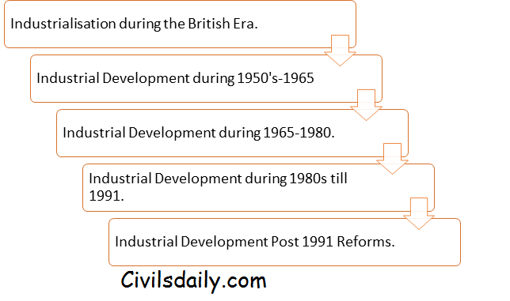
Industrialisation during the British Rule
Indian Industry had a global presence before the advent of Britishers in India. Before the advent of British in India, India accounted for a quarter of World’s Industrial output.
The exports from India consisted of manufacturers goods like cotton, silk, artistic ware, silk and woollen cloth.
The impact of British Policies and the Industrial Revolution led to the decay of Indian handicraft industry. Post-Industrial revolution in Britain, machine-made goods starting flooding into the Indian markets.
The decline of traditional handicraft was not followed by the rise of modern Industrialisation in India due to the British policy of encouraging the imports of British made goods and exports of raw materials from India.

The First Phase (1950-1965): Industrial Sector at the Time of Independence
The main features of the Indian Industrial sector on the eve of the Independence were:
- There were majority of consumer goods industries vis-à-vis producer goods/capital goods industries resulting in lopsided industrial development. The ratio of consumer goods industries to producer good/capital goods industry was 62:38 during the early 1950s.
- The Industrial sector was extremely underdeveloped with very weak infrastructure.
- The lack of government support to the industrial sector was considered as an important cause of underdevelopment.
- The structure and concentration of ownership of the industries were in few hands.
- Technical and Managerial skills were in short supply.
As a result of these shortcomings, the national leadership reached on a consensus that economic sovereignty and economic independence lay in the rapid industrialisation including the development of Industrial Infrastructure.
The First Five-year Plan did not envisage any large-scale programs for industrialisation. The plan rather made an attempt to give a practical shape to the Indian economy by providing for the development of both private and public sector. A number of industries were set up in the public sector. Important among those were Hindustan Shipyard, Hindustan Tools, Integral Coach Factory etc.
The Second Five-Year plan accorded highest priority to Industrialisation. The plan was based on famous Mahalanobis Model. Mahalanobis model set out the task of establishing basic and capital goods industries on a large scale to create a strong base for the industrial development. The plan includes substantial investment in the Iron and Steel, Coal, Heavy engineering, Machine building, Heavy Chemicals and Cement Industries of basic importance.
The Third Plan followed the strategy of the Second plan by establishing basic capital and producer good industries with the special emphasis on machine building industries. As a result, the second and the third plan placed great emphasis on building up the capital goods industries. Most of the capital good industries are built under the Public Sector.
The First Three-Five Year Plans are important because their aim was to build a strong Industrial base in India. This first phase of Industrial development in India laid the foundation for strong Industrial Phase.
As a result, the first Three Plans witnessed a strong acceleration in the growth rate of the Industrial production. The period witnessed an increase in growth rate from 5.7% to 7.2% and ultimately 9.0% in the first, second and third plans respectively.
The most important observation of the period was that the rate of growth of capital good industry considered as the backbone of modern industrialisation grew at 9.8%, 13.1% and 19% during the first, second and third plan respectively.

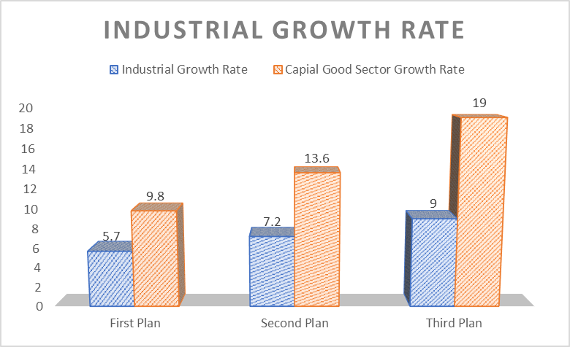Source: Government of India, Handbook of Industrial Statistics

The Second Phase (1965-1980): The Period of Industrial Deceleration
The first three five-year plans mostly focused on the development of the Capital Good sector. As a result, the consumer goods sector was left neglected. The consumer goods sector also known as wage good sector is considered to be the backbone of the rural economy and its complete neglect had resulted in fall in the growth rate of industrial
production as well as of the overall economy.
The Wage Goods Model: Prominent Economist like, C N Vakil and P R Brahmananda advocated Wage Good model for the development of the Indian economy and Industrialisation. Vakil and Brahamanda differed from the Mahalanobis strategy as they believe “At the low level of consumption (this was the situation in India) the productivity of the workers depends on how much they consumed. According to them, if people were undernourished, they will lose their productivity and become less efficient, at this juncture it is necessary to feed them to increase their productivity. But this is not true for all consumer good; so they differentiated between Wage Good (whose consumption increase worker productivity) and Non-Wage Good (whose consumption did not).
To sum up, Wage Good model says; worker’s productivity depends on not on whether they use machines to produce goods but also on the consumption of wage goods like, food, cloth and other basics. Therefore, the first step towards development is to mechanize agriculture and raise food production; once this objective is reached, one should go for Mahalanobis strategy of Heavy Industrialisation.
Anyway, Vakil and Bharmananda strategies were ignored and India launched heavy Industrialisation in the Second plan without mechanising agriculture. The result was failure of Mahalanobis Strategy and by 1965-66 India was hit by a severe food shortage crisis. Finally, in the wake of the crisis, the government adopted Bharamananda strategy of mechanizing agriculture sector and engineered green revolution.
The period between 1965 to 1975 was marked by a sharp fall in the industrial growth rate. The rate of growth fell from 9.0% during the third plan to a mere 4.1% during the period of 1965-75. The growth rate fell to 5.3% in 1965-66, 0.6% in 1966-67, then recovering a little in the succeeding years.
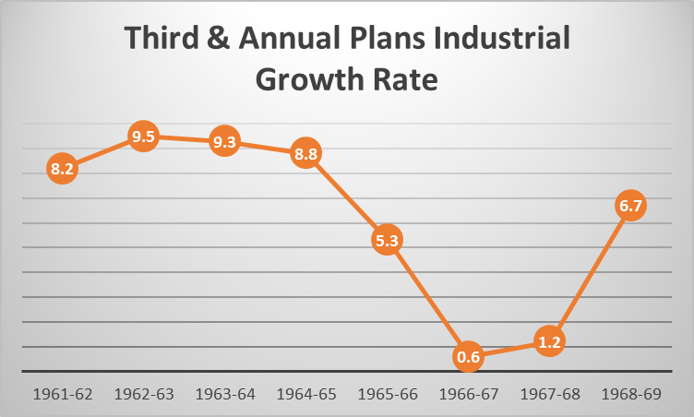

Source: Ministry of Commerce, GOI.

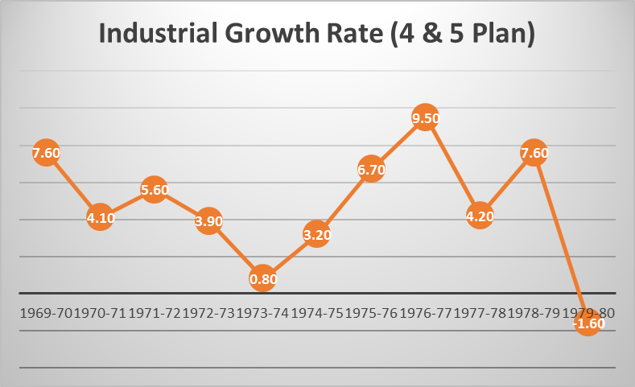Source: Ministry of Commerce, GOI.
The deceleration it the growth rate is evident during the fourth and fifth plan. The industrial growth rate fell from 5.6% in the year 1971-72 to 0.8% in the year 1973-74. At the end of the fifth plan in 1979-80, the industrial growth rate fell to negative 1.6%.
The period of 1965-80 is also marked as the period of structural retrogression, where the growth rate of the capital good sector and basic industries also fell.
Causes of Deceleration and Retrogression.
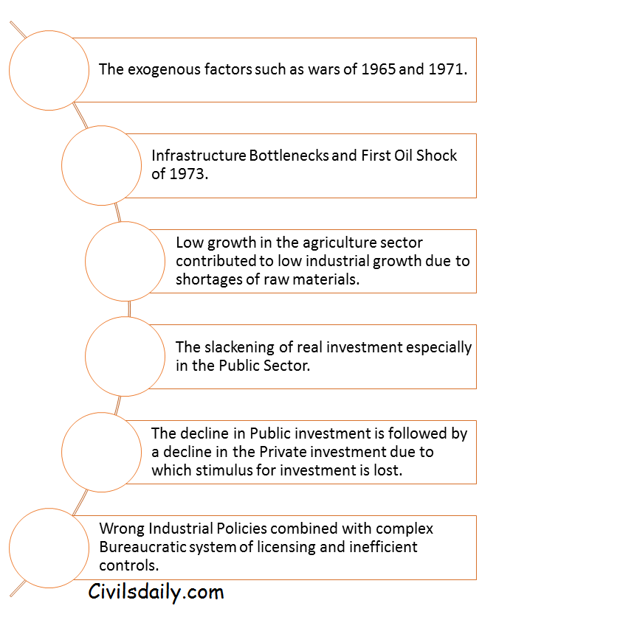

Phase Three (1980-1991): Industrial Recovery
The period of the 1980s can be considered as the period of the Industrial recovery. The period saw a revival in the industrial growth rates. The period witnessed an industrial growth rate of more than 6 percent during the sixth plan and 8.5 percent during the seventh plan. The period was also marked by a significant recovery in the manufacturing and capital good sector. The most important observation from the revival of industrial sector was that the revival is closely associated with the increase in the productivity of Indian Industries.

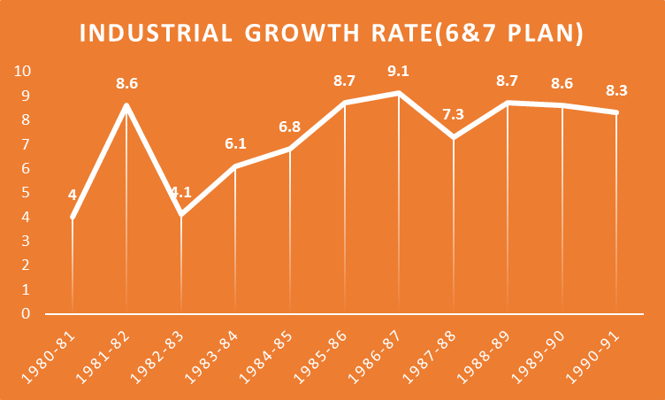

Source: Ministry of Commerce, GOI.

Causes of Industrial Recovery
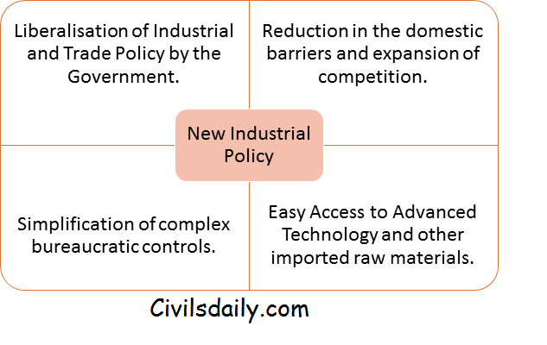
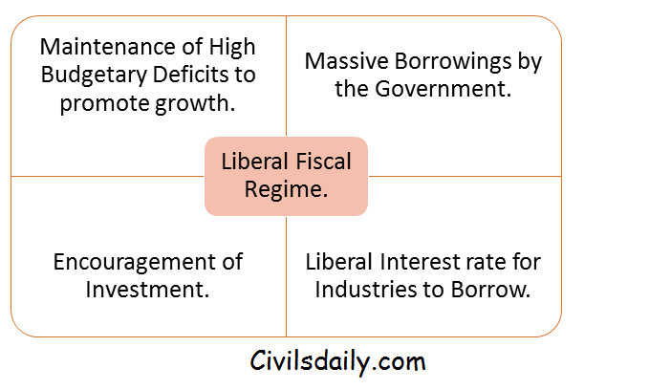
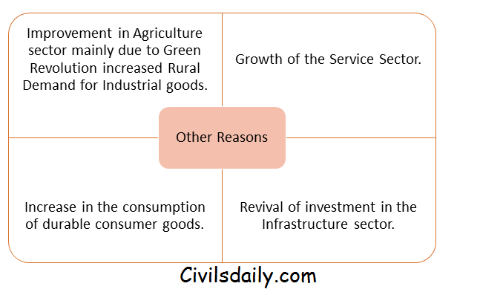

Phase Four (Post Reform Period)
The year 1991 ushered a new era of economic liberalisation. India took major liberalisation decision to improve the performance of the industrial sector.
- Abolishment of the Industrial Licensing.
- Simplification of the procedures and regulatory requirement to start a business.
- Reduction in the sector exclusively reserved for the Public sector.
- Disinvestment of the selected Public-sector undertakings.
- Foreign investors were allowed to invest in the Indian firms.
- Liberalisation of the trade and exchange rate policies.
- Rationalisation and massive reduction in the structure of Customs Duties.
- Reduction in the excise duties.
- Reduction in the Income and Corporate taxes to promote Business.
To analyse the impact of these reforms measures on the industrial growth, it is better to divide the period into two:- The period of the 1990s and The Period since 2002-03
The period of the 1990s
- The average annual growth rate of the industry which was close to 8% in the post-reform period fell to 6% in the 1990s.
- The growth rate in the Eighth Plan was 7.3 percent which was same as the targeted growth rate.
- The growth rate in the Ninth Plan was 6.0 percent which was significantly less than the targeted rate of 8.2 percent.
- Further, the sector witnessed its worst ever performance in the last few years of the Ninth plan with growth collapsing to just 2 percent.
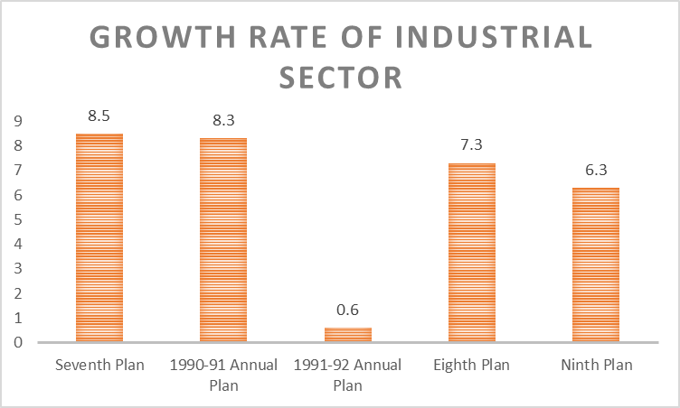

SOURCE: MINISTRY OF COMMERCE, GOI.
Causes of Slow Industrial Performance.
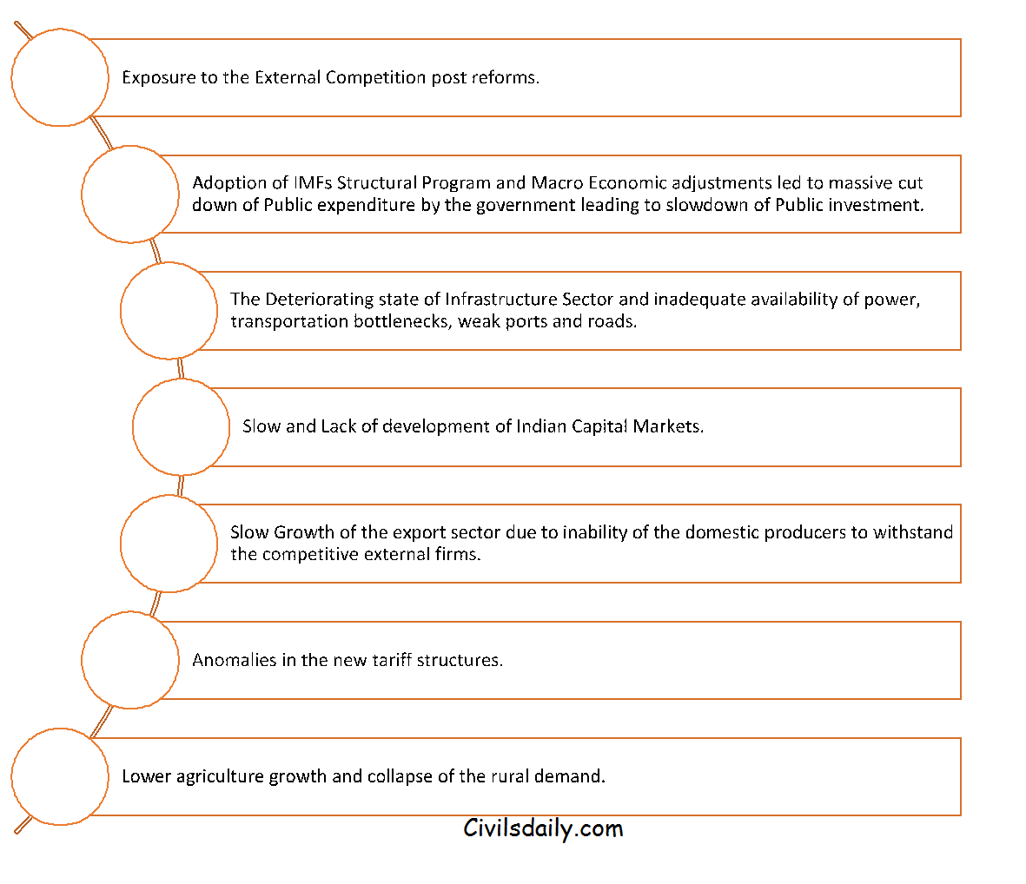The Period since 2002-03:
The period since the new millennium witnessed a sharp recovery and revival of the industrial sector. The tenth and eleventh plan witnessed a high growth rate of industrial production.
The rate of growth of the industrial sector was 5 percent during the initial years of the Tenth Plan. The growth picked in the following years and reached 7% in 2003-04, 8% in 2004-05 and 11% in 2006-07. For the plan as a whole, the growth rate was 8.2 percent.
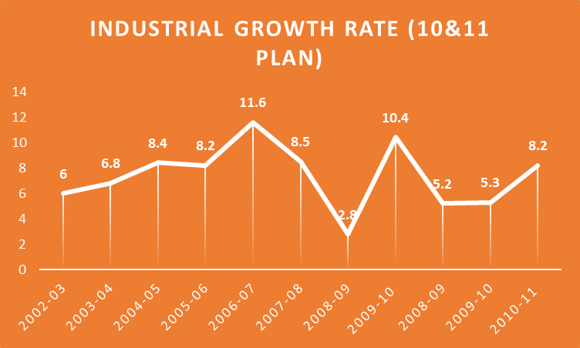
Source: Ministry of Commerce, GOI.
The growth in the Tenth plan was mainly driven by the manufacturing sector. The significant acceleration in the capital good sector was the significant contributor to the overall economic growth.
During the Eleventh Plan, the industrial growth witnessed a considerable degree of fluctuations. After growing at more than 8 percent, the growth collapsed to 2.8 percent in the year 2008-09. The main reason for the collapse was the Global Financial crisis that hit the World in the year 2008.
The industrial growth started recovering in the year 2009-10 and touched a high of 10 percent. The industrial growth after some setbacks again recovered in the year 2010-11 to reach 8.2 percent.
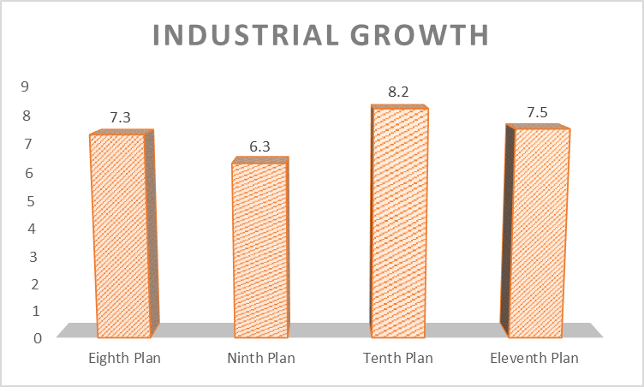

Source: Ministry of Commerce, GOI.
The period post-2011 till now.
The period starting from 2011-12 saw a severe slowdown in the industrial growth and production. The slowdown during the period is due too.
- Weak Demand for exports from the Developed Western Countries due to Global Financial Crisis.
- The slowdown in the Domestic Demand.
- High Interest in India maintained by the RBI, due to persistently high Inflation.
- The slowdown in the Private Investment by the private sector due to weak returns on the investments.
- Rising NPAs of the Public-Sector banks has led to weak credit and lending offered by them.
- Failure of past projects of the private sector.
- Government reluctance to increase Public investment due to the stand of maintaining a low fiscal deficit.
- Uncertain Global Recovery.
- European Debt Crisis.
- The slowdown in the prices of commodities in International Commodity markets mainly due to weak Chinese growth. The weakness in the prices has hit the Indian agriculture sector where prices of the Agriculture commodities has remained low, leading to collapse of income in the rural areas.
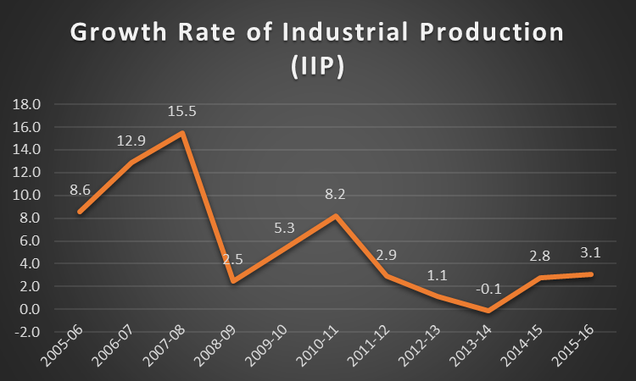Source: Ministry of Commerce, GOI.
The annual growth rate of IIP has been decelerating post-2011. The IIP fell from 8.2% in 2010-11 to 2.9% in 21011-12. The IIP further fell to 1.1% in 2012-13, negative 0.1 percent in 2013-14 and 2.8% in 2014-15.
Trends of Plan-Wise Industrial Growth Rate.

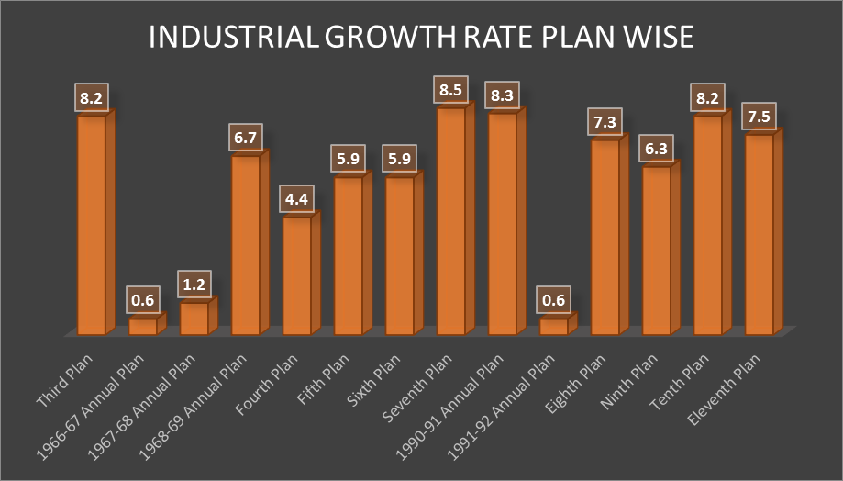Source: Ministry of Commerce, GOI.

