Inflation vs Interest Rate Relationship
Here we provide you with the top relationship between Inflation and Interest Rate
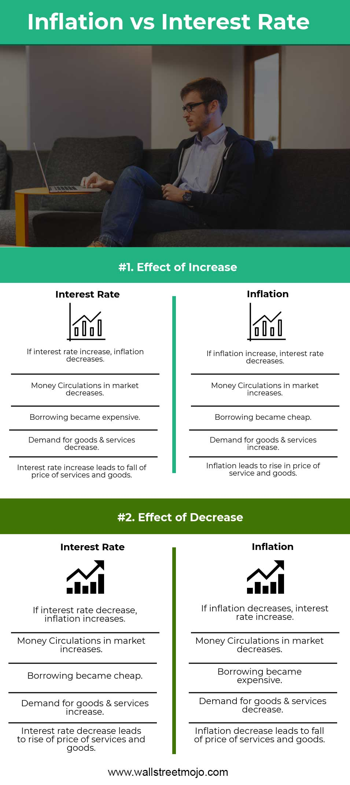

The relationship between Inflation and Interest Rate
- Quantity Theory of Money determines that supply and demand for money determine inflation. If the money supply increases, as a result, inflation increase and if money supply decreases lead to a decrease in inflation.
- This principle is applied to study the relationship between inflation vs interest rate where when the interest rate is high, supply for money is less and hence inflation decrease which means supply is decreased whereas when the interest rate is decreased or low, supply of money will be more and as a result inflation increase that means that demand is increased.
- In order to control high inflation, the central bank increases the interest rate. When interest rate increases, the cost of borrowing rises. This makes borrowing expensive. Hence, borrowing will decrease and the money supply will fall. A fall in money supply in the market will lead to a decrease in money with people to expense on goods and services. With the supply constant and the demand for goods and service will decrease which leads to falling of the price of goods and services.
- In a low inflationary situation, the rate of interest reduces. A decrease in the rate of interest will make borrowing cheaper. Hence, borrowing will increase and the money supply will increase. With a rise in the money supply, people will have more money to spend on goods and services. So, demand for goods and services will increase and with supply remaining constant this leads to a rise in the price level and that is inflation.

